**COGNIZANT SERVICENOW**

Week-1 Understanding Document

**1.What is ServiceNow**

Who is ServiceNow- It is all employees over 17000 people, Customers BillMcDermott ,Fred Luddy.

When- In 2003 fred luddy founded company as Glidesoft

In 2006- Glidesoft to Servicenow

In 2012- now becomes traded company

In 2018- it is no.1 on most innovative companies

In 2019-bill named as he is CEO of it

Why Servicenow - Information technology

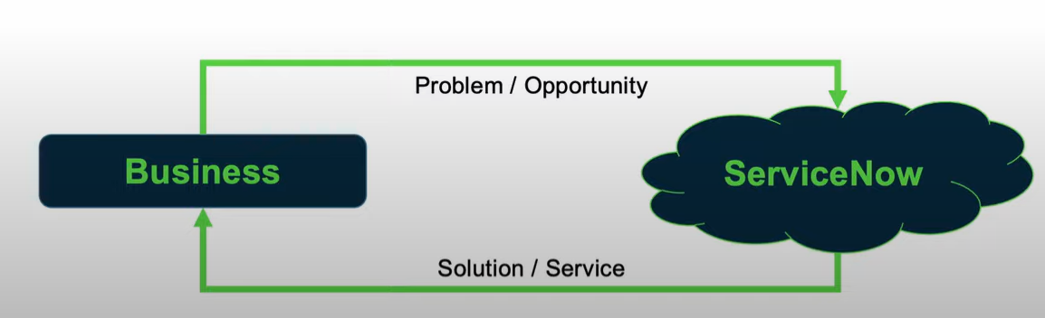

How servicenow –

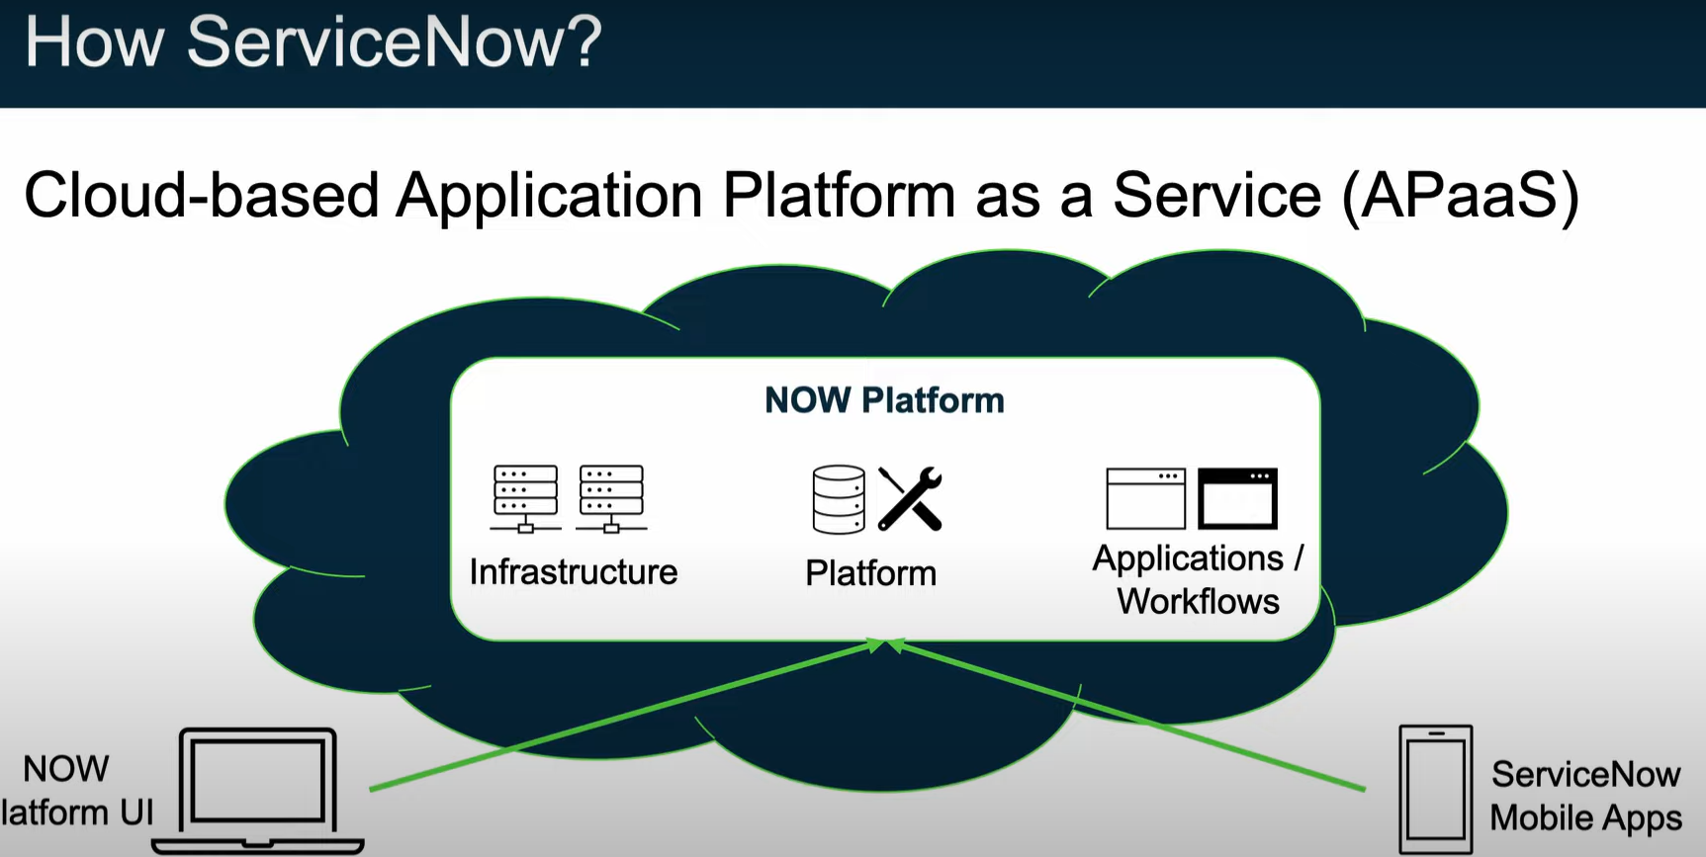

Infrastructure- Compute resources, security, service level agreements Backups.

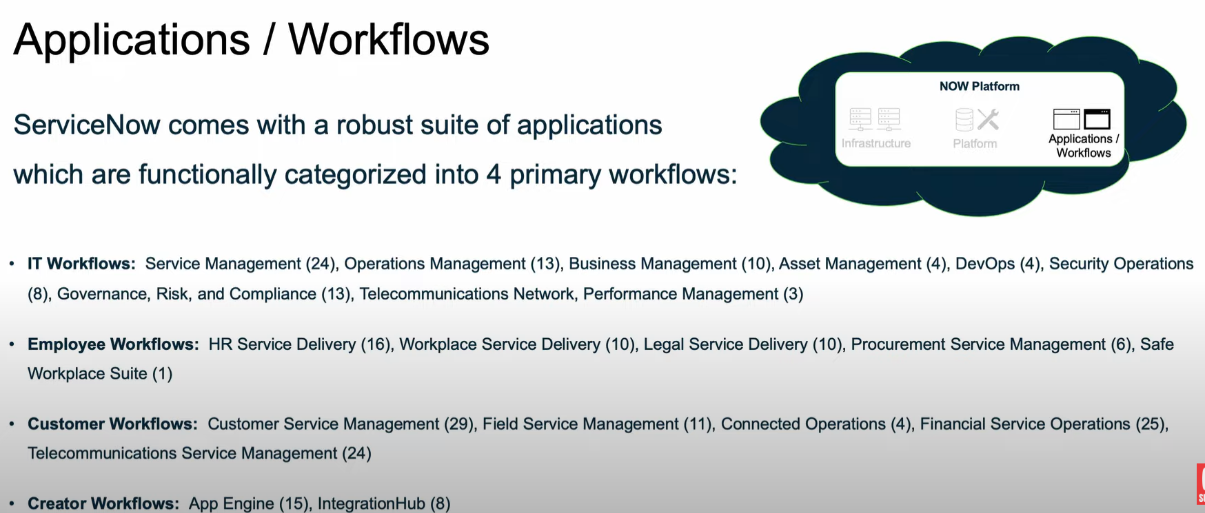

Where is it-

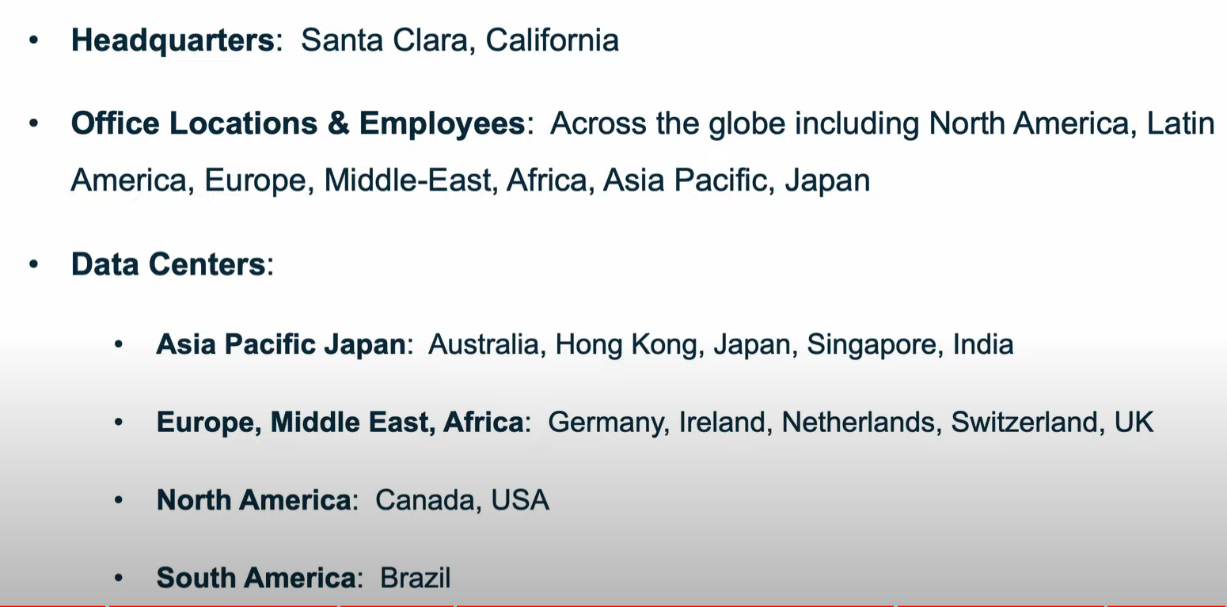

What is servicenow-

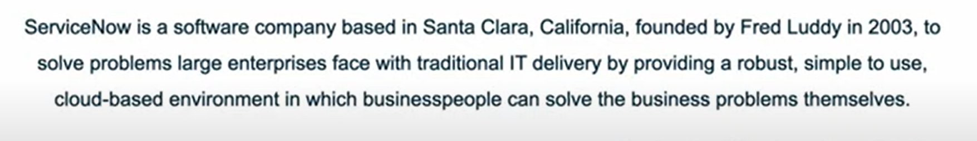

**2. Servicenow Platform Overview**

Now platform is known as Apaas.

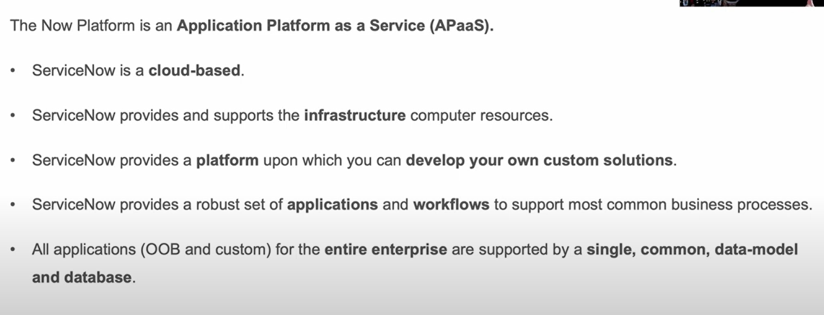

Applications and workflows-

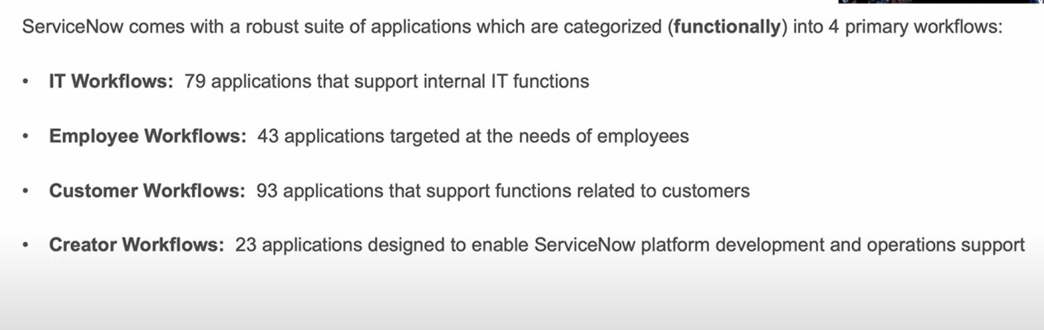

Platform Architecture-

Enterprise cloud: Servicenow is built on multi instance architecture.

Availability and Redundancy: Redundancy is built into every layer includes devices, power and network resources.

Backups :4 weekly bakups and 6 days of daily differential backups

Domain separation : separate in to logical groups

Servicenow platform provides user interfaces -

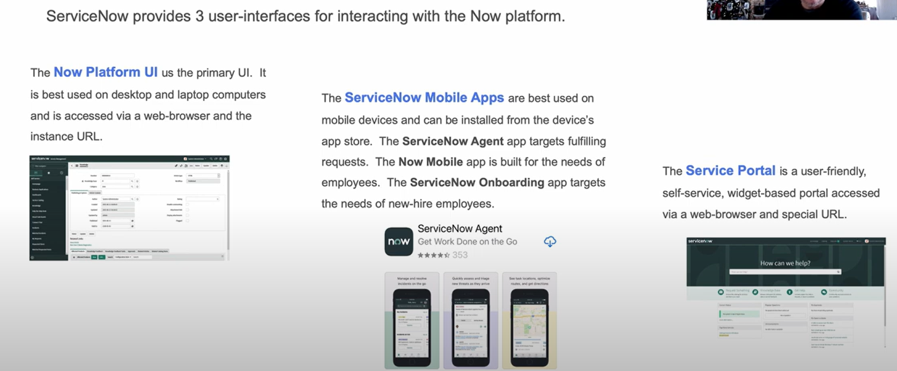

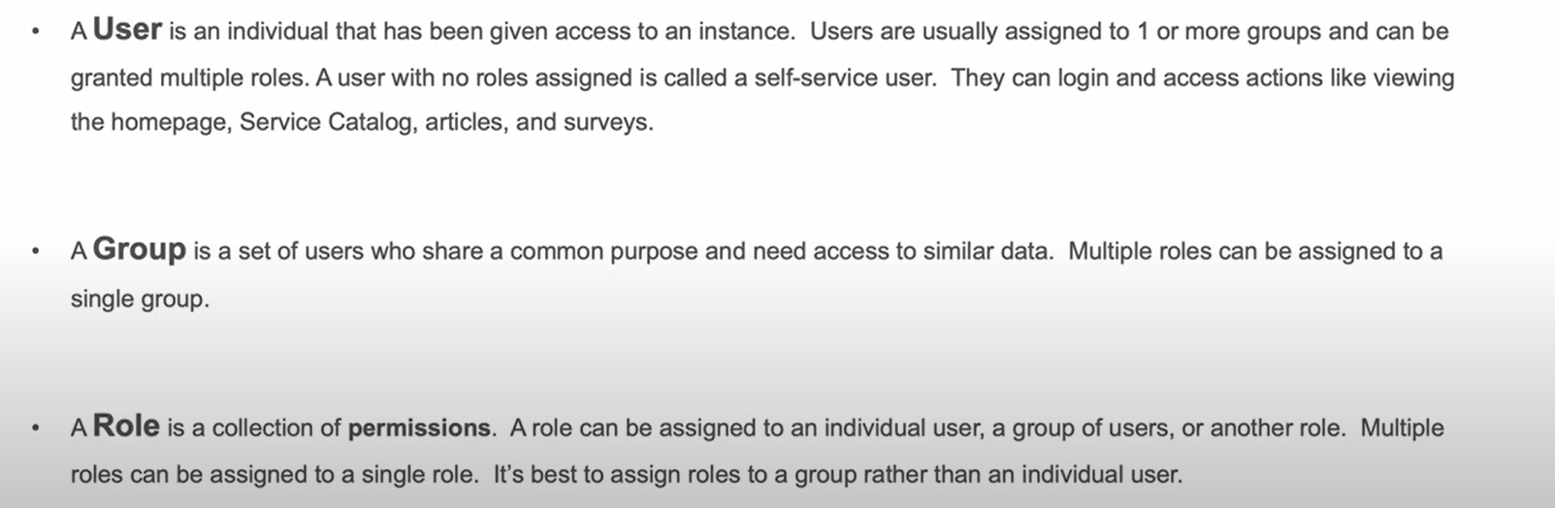

User authentication-

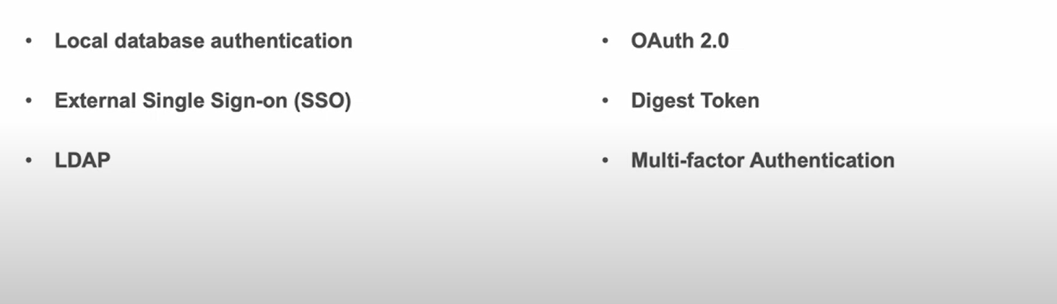

**3. ServiceNow User Interface Overview**

Bannerframe-

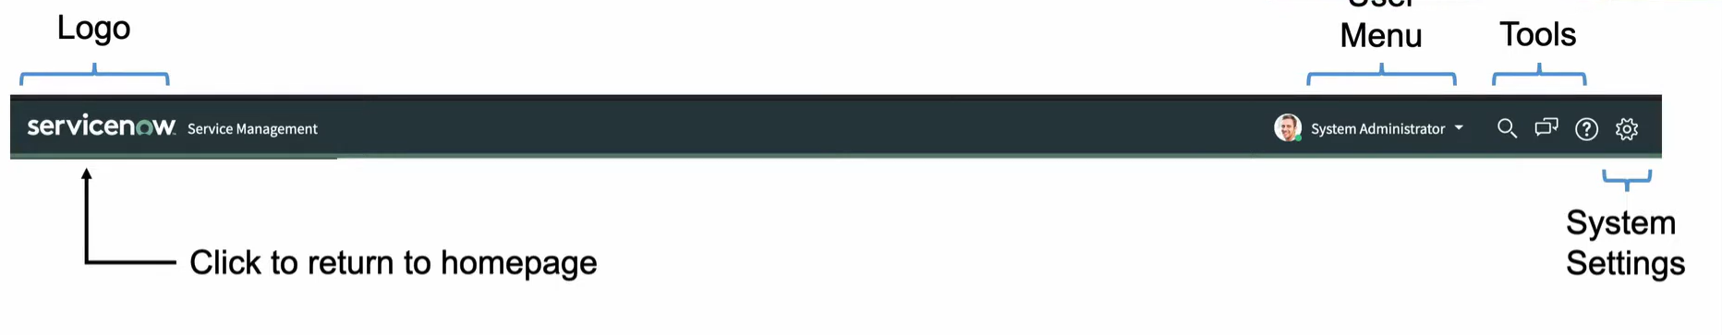

The user menu provides these tools: Profile, impersonate user, elevate roles , logout.

Banner frame provides tools- Global search, connect chat, Help.

**System settings in banner frame-**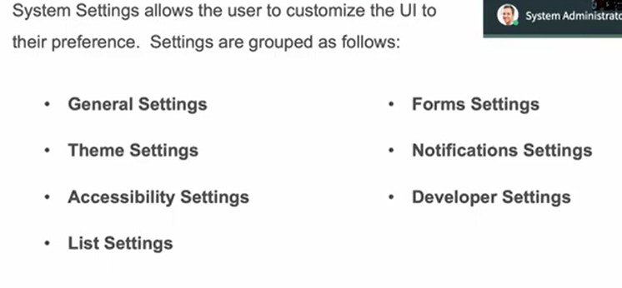

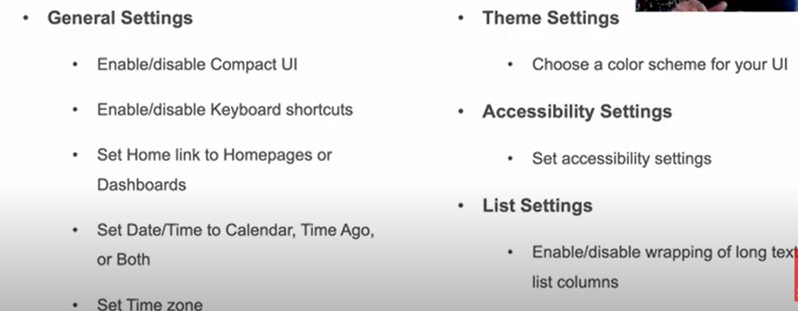

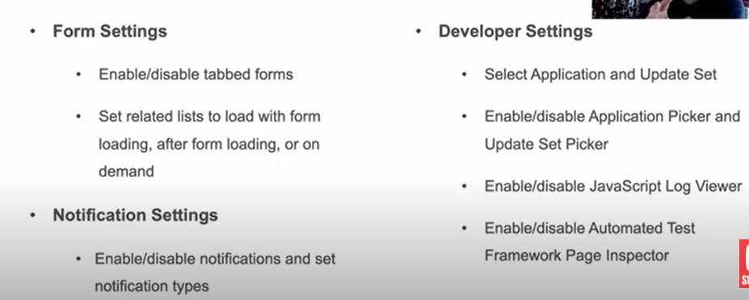

**Application Navigator-**

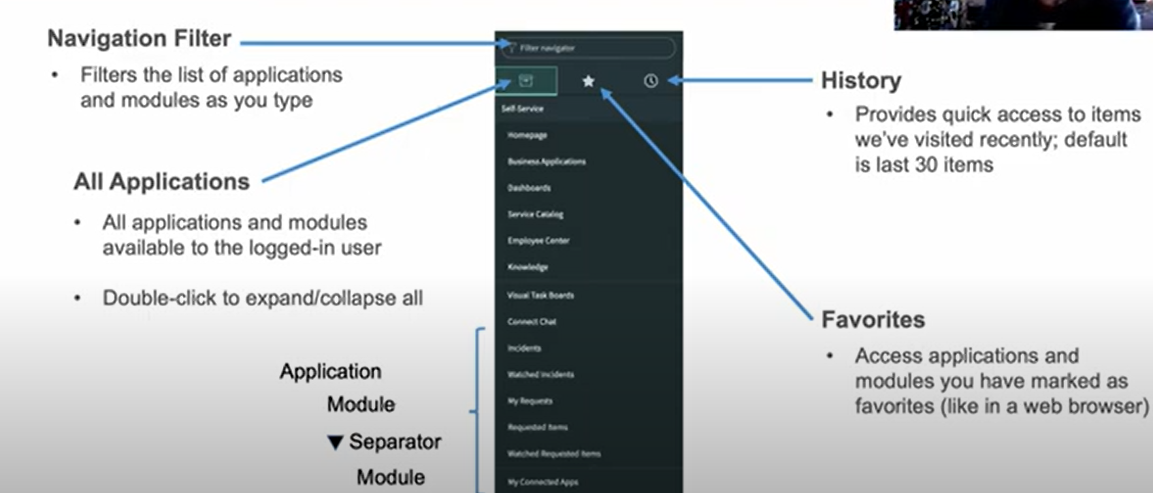

**4. Servicenow Branding Overview**

Branding-

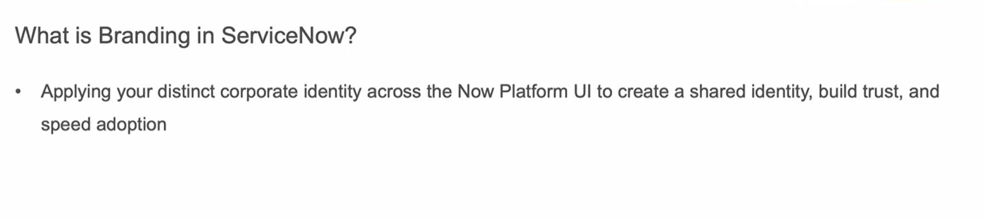

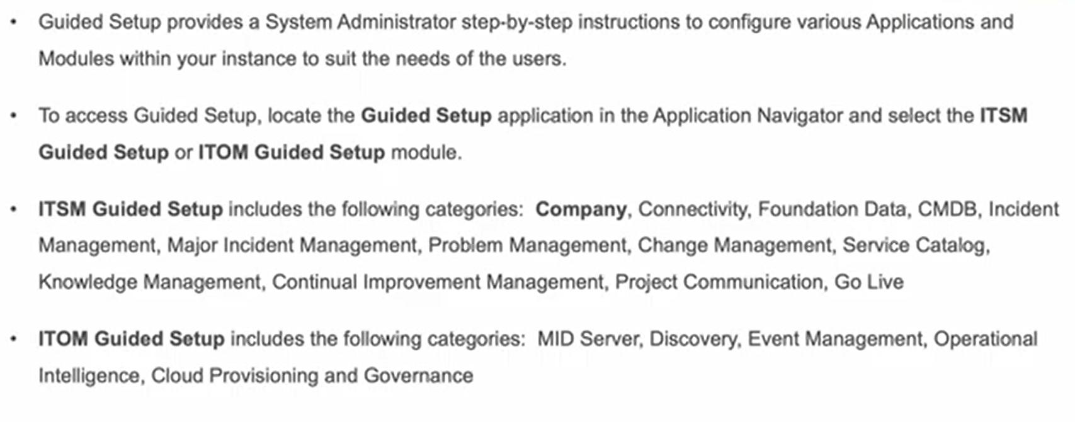

Service portal- widget based tool that allows creation of intuitive user friendly interfaces to now platform.

UI builder- build out functional page by choosing library of components and layouts.

**5. Servicenow lists and filters**

To access the list-

1.Incident in application navigator -> all -> open the list

2.Tablename.list

3.If we don’t know the table name we use – sys_db_object.list

**List interface header-**

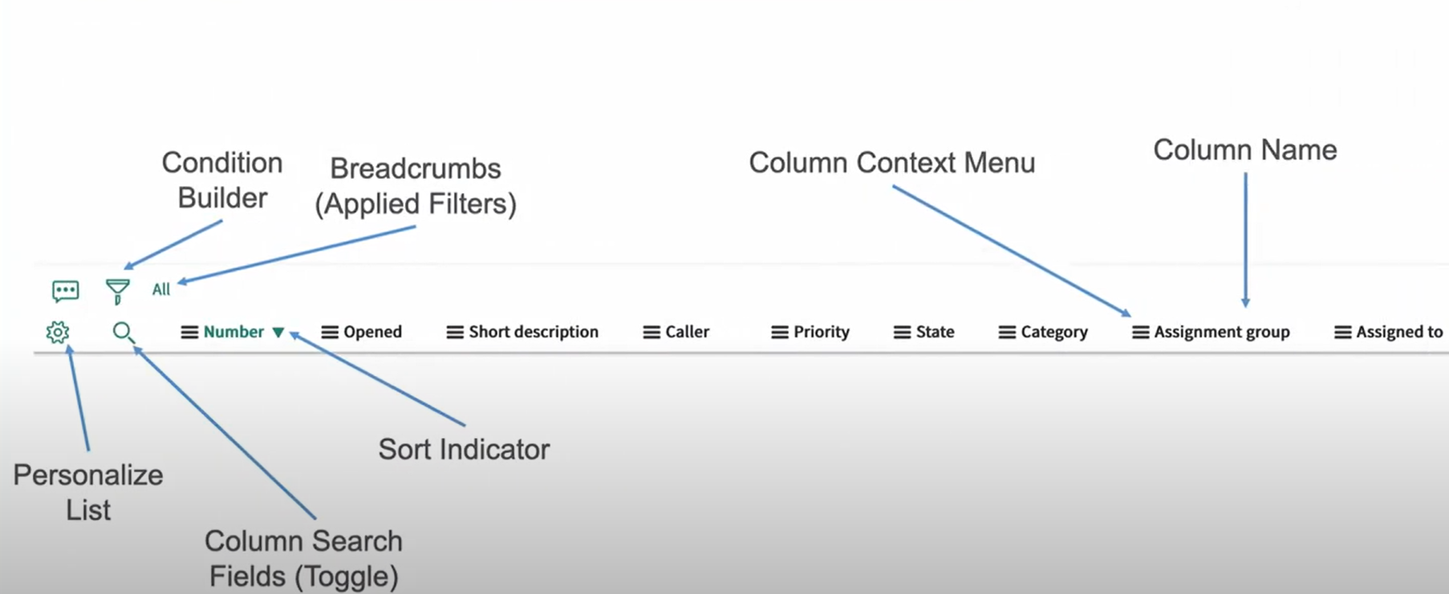

Personalize list

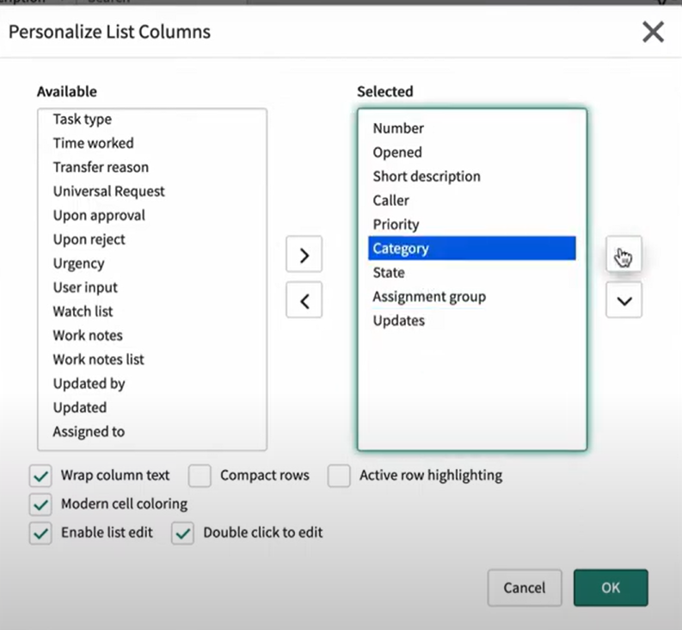

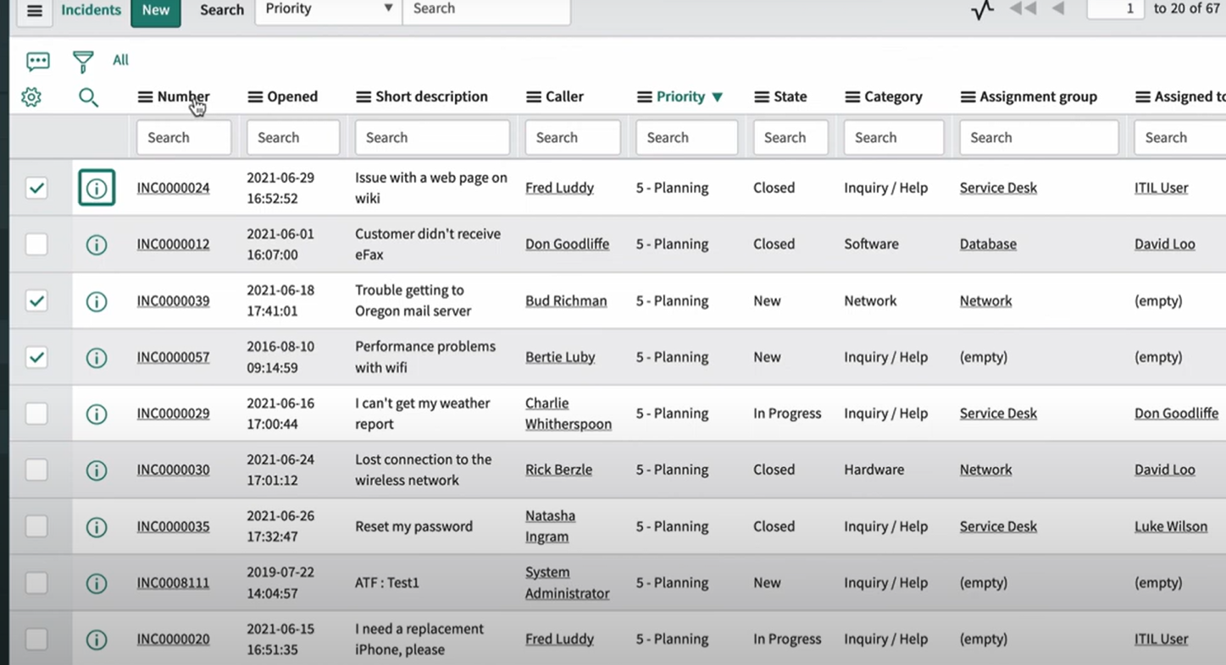

**6. Forms in service now**

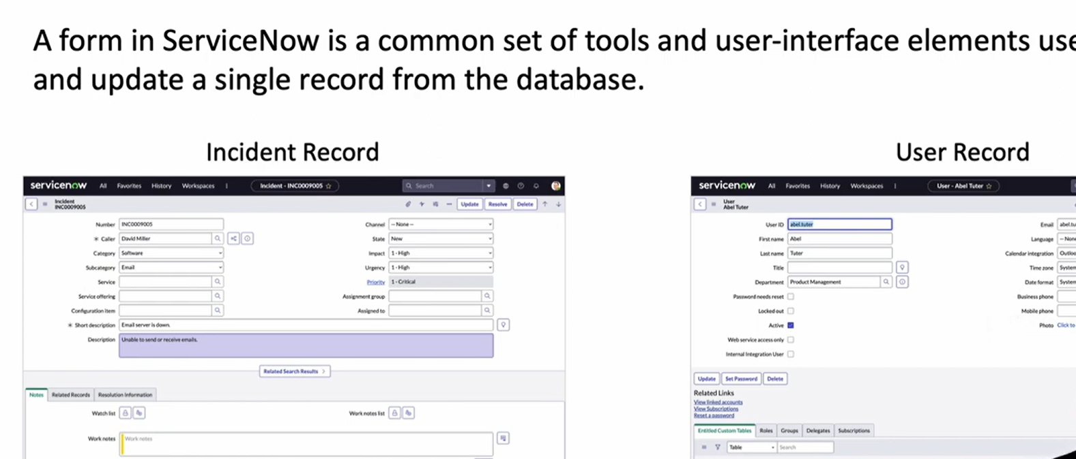

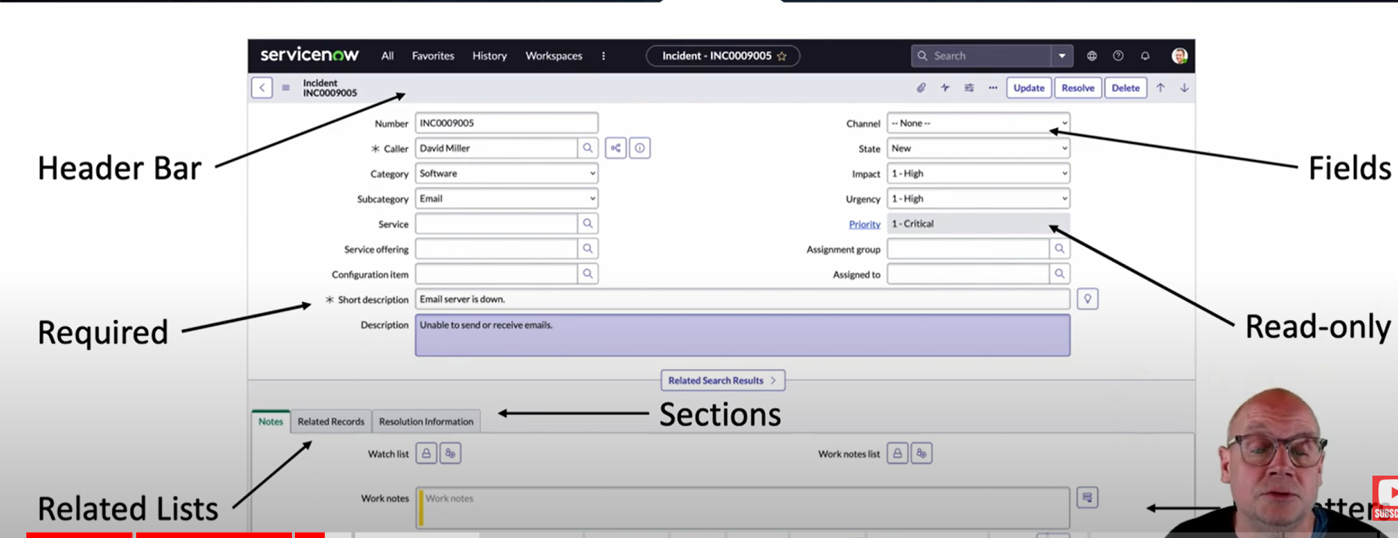

Form field types-

String filed

Boolean field

Choice field

Reference field

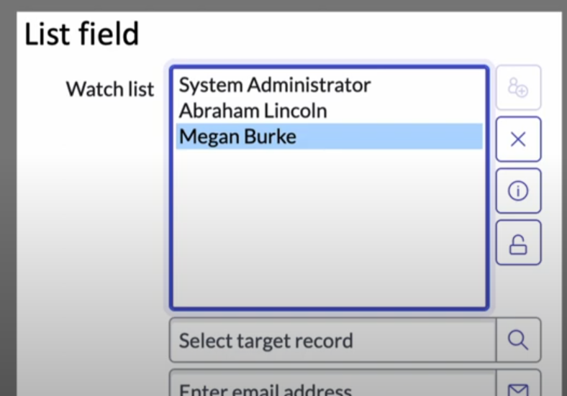

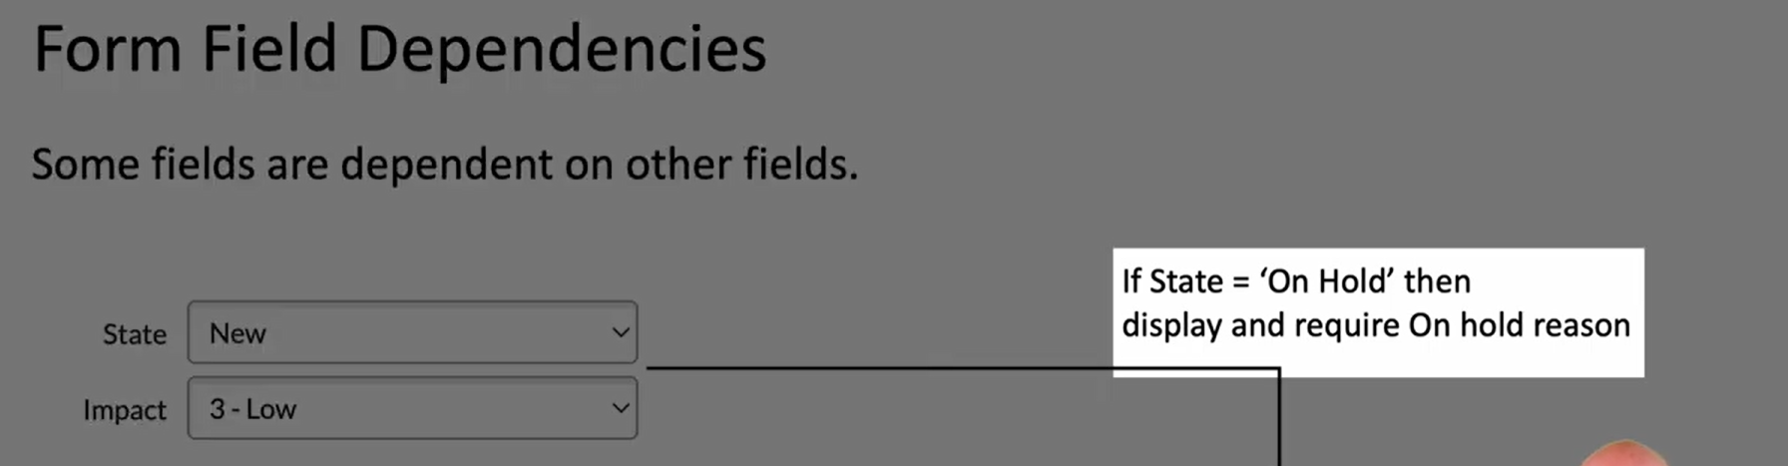

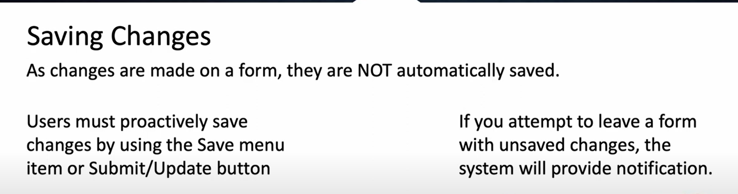

Copying –

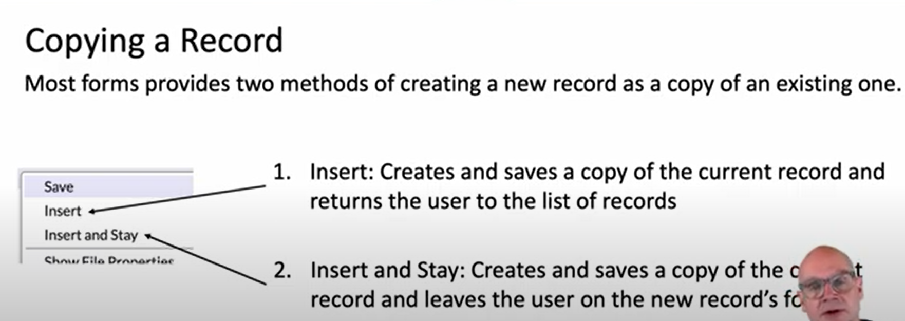

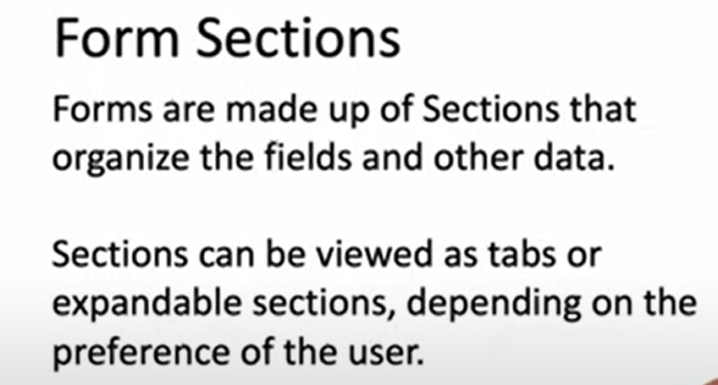

Tabbed section

Expandable section

**Form related list**

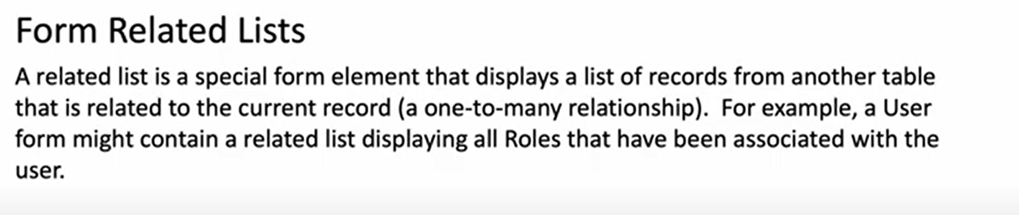

Form formatter- A special form element that displays information like history.

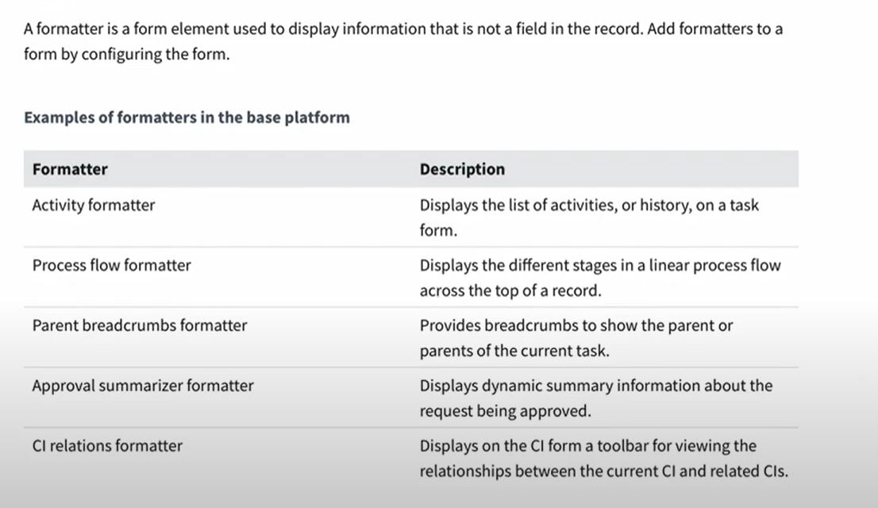

Form views

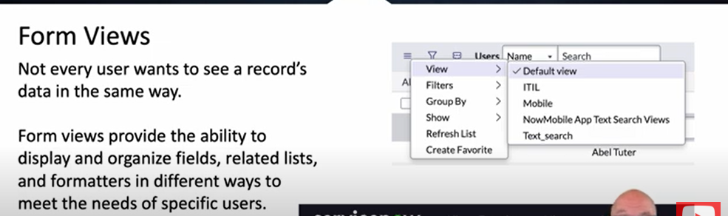

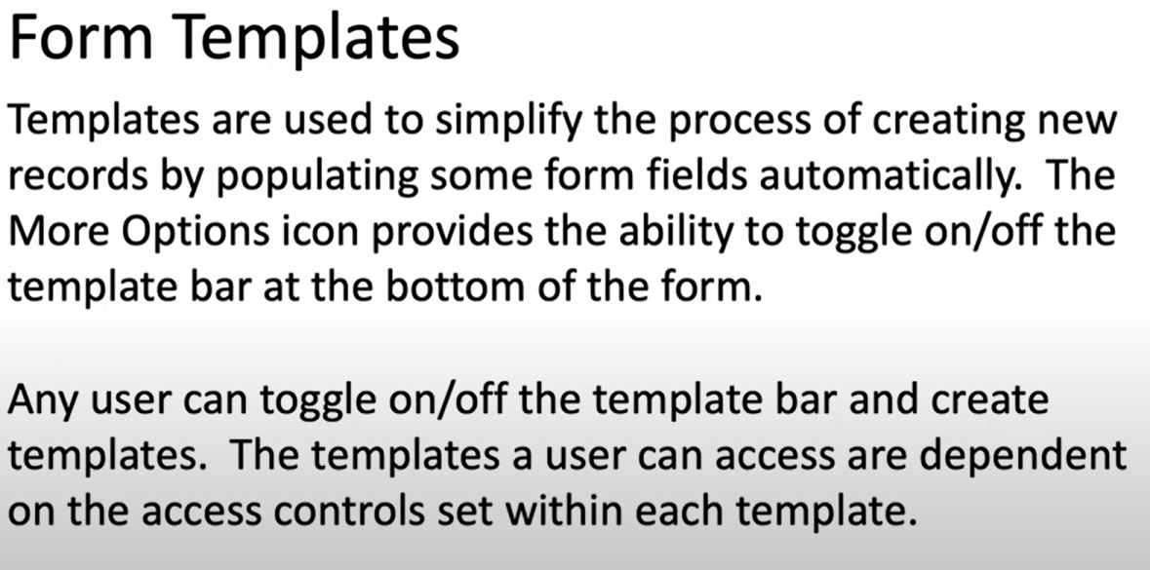

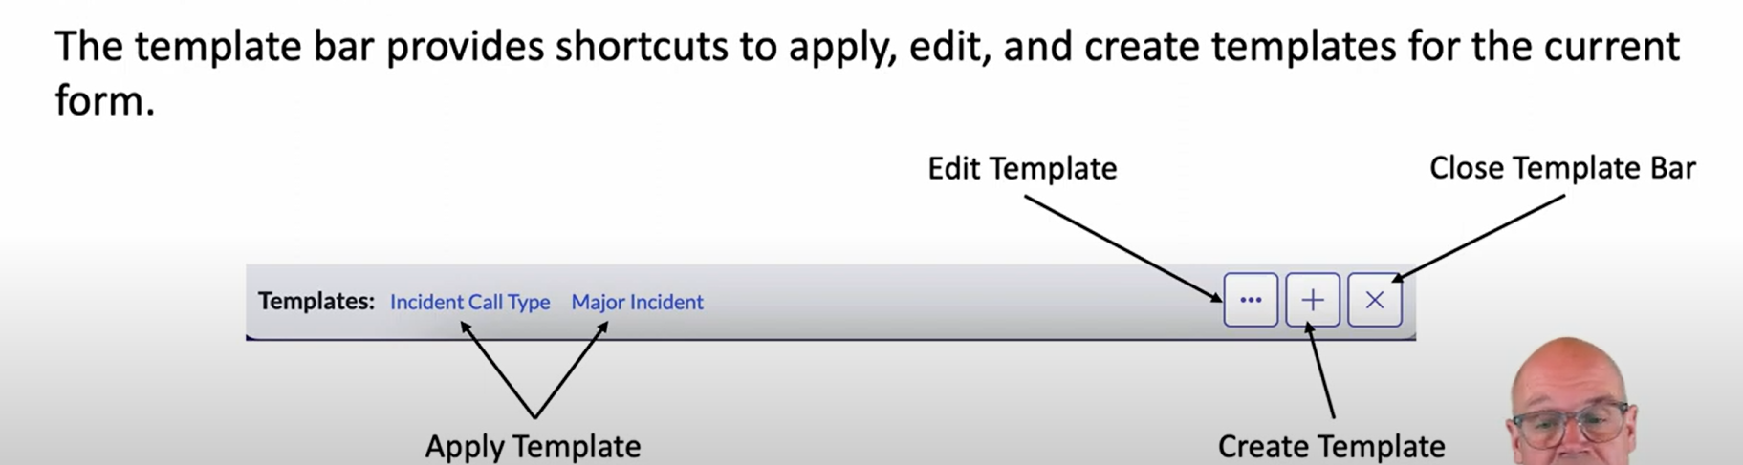

For creating and managing form two tools-

Form design

Form layout.